**Name: Steven Jordan**

**Date: 6/14/2021**

**Project Title: Iowa Liquor Sales**

**Dataset and Business Use Case**

I am putting myself in the shoes of a new Data Scientist working for the Iowa Department of Commerce tasked with understanding and optimizing the liquor retail sales channels. Currently, all liquor sales go through the state who work as an intermediary between vendors and liquor stores. This means that the department is in a position to help stores better understand what items to stock based on what items sell and which items would be likely to sell at their store.

I’ve selected Washington county specifically as a pilot program because of their size (131k total orders) as well as their number of vendors and stores (232 and 22). The data is hosted on Google BigQuery in the public data section.

[Data Link](https://console.cloud.google.com/marketplace/product/iowa-department-of-commerce/iowa-liquor-sales?project=consumer-analytics-youtube-api)

**Graph Data Model**

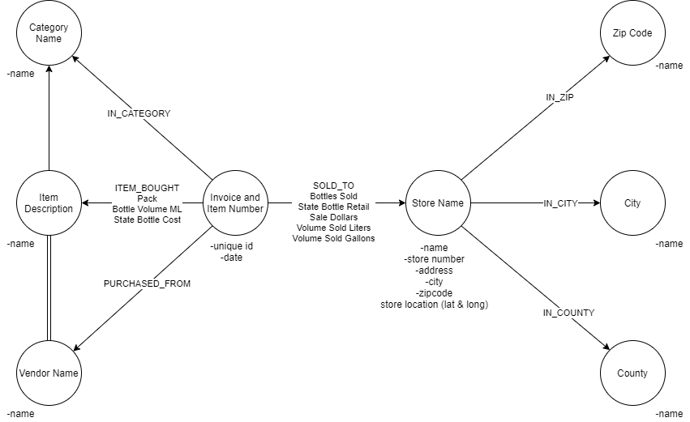

**Graph Projections**

Utilizing the below graph projections, I will be able to easily see what items each store purchases along with what vendor each store ultimately purchases from.

